 | vCenter Plug-in
 | User Guide
 | Issue | 01
 | Date | 2017-09-29


Preface
Purpose
This document describes the installation and operation and maintenance (O&M) of the Huawei vCenter plug-in.
Intended Audience
This document is intended for:
- Technical support engineers
- System maintenance engineers
Symbol Conventions
The symbols that may be found in this document are defined as follows.
Symbol | Description
 | Indicates an imminently hazardous situation which, if not avoided, will result in death or serious injury.
 | Indicates a potentially hazardous situation which, if not avoided, could result in death or serious injury.
 | Indicates a potentially hazardous situation which, if not avoided, may result in minor or moderate injury.
Indicates a potentially hazardous situation which, if not avoided, could result in equipment damage, data loss, performance deterioration, or unanticipated results.
NOTICE is used to address practices not related to personal injury.
Calls attention to important information, best practices, and tips.
NOTE is used to address information not related to personal injury, equipment damage, and environment deterioration.

Change History
Changes between document issues are cumulative. The latest document issue contains all the changes made in earlier issues.
Issue 01 (2017-09-29)
This issue is the first official release.
Contents
Preface ii
1 Overview 1
2 Installing and Uninstalling the Huawei vCenter Plug-in 3
2.1 Installing the Huawei vCenter Plug-in 3
2.2 Uninstalling the Huawei vCenter Plug-in 7
3 Operation and Maintenance 14
3.1 Configuring eSight 14
3.1.1 Adding eSight 14
3.1.2 Editing eSight 16
3.1.3 Deleting eSight 18
3.2 Managing Servers 18
3.2.1 Viewing the Server List 18
3.2.2 Deploying an OS 19
3.2.2.1 Adding a Software Source 19
3.2.2.2 Creating an OS Template 21
3.2.2.3 Creating a Template Task 23
3.2.3 Managing Templates 25
3.2.3.1 Configuring Power Control 25
3.2.3.2 Configuring the BIOS 26
3.2.3.3 Configuring an HBA 34
3.2.3.4 Configuring RAID 36
3.2.3.5 Configuring a CNA 38
3.2.3.6 Configuring the iBMC 41
3.2.4 Upgrading the Firmware and Driver 44
3.2.4.1 Uploading an Upgrade Package 44
3.2.4.2 Upgrading the Firmware and Driver 46
3.3 Viewing the Huawei vCenter Plug-in Version 48

Overview
The Huawei vCenter plug-in is a server management plug-in deployed in vCenter. It is compatible with vCenter 6.0 and vCenter 6.5, and is also compatible with eSight V300R008C00SPC201 or later.
The Huawei vCenter plug-in provides the following functions:
- Views server information and component information.
- Uploads and manages software sources, and deploys server OSs in batches. The OSs include Windows, SUSE Linux Enterprise Server, Red Hat Enterprise Linux, CentOS, Ubuntu, and VMware ESXi.
- Configures CNAs, HBAs, BMCs, BIOSs, and RAIDs of servers.
- Upgrades server firmware and drivers.
- Views the current version of the Huawei vCenter plug-in.
Table 1-1 lists the servers supported by the Huawei vCenter plug-in.
                - Supported servers
Type | Server
Rack server | RH1288 V3
Rack server | RH2288H V2
Rack server | RH2288 V3
Rack server | RH2288H V3
Rack server | RH5885 V3
Rack server | RH5885H V3
Rack server | RH8100 V3
Rack server | 1288H V5
Rack server | 2288H V5
Rack server | 2488 V5
Blade server | E9000
High-density server | X6000
High-density server | X6800

Installing and Uninstalling the Huawei vCenter Plug-in

Installing the Huawei vCenter Plug-in
Prerequisites
- JRE 1.8.0 or later has been installed on the vCenter server.
- You have obtained the Huawei vCenter plug-in installation package vCenter-plugin-1.0.zip and deployment program package vcenter-deployer-1.0.jar.
Procedure
            - Log in to the vCenter server as the administrator, and upload the Huawei vCenter plug-in installation package and deployment program package to the vCenter server.
The Huawei vCenter plug-in installation package and deployment program package must be stored in the same path.
            - Modify the Java environment variable.
Windows Server 2012 R2 is used as an example.
- In Control Panel, choose System and Security > System > Advanced system settings.
The System Properties dialog box is displayed.
- On the Advanced tab, click Environment Variables, as shown in Figure 1-1.
              - System Properties
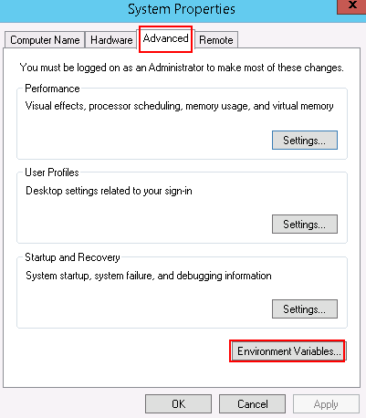

The Environment Variables dialog box is displayed.
- In the System variables area, select the Path variable, and click Edit.
The Edit System Variable dialog box is displayed.
- Add a variable value, and click OK.
For example, add C:\Program Files\Java\jre1.8.0_121\bin to Variable value, as shown in Figure 1-2.
              - Edit System Variable
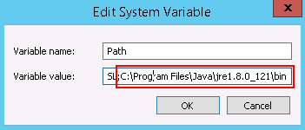

- Click OK.
- Click Apply, and click OK.
- Run CMD to access the CLI, and enter java -version to view the JRE version.
            - Decompress the deployment program package.
            - Run CMD to access the CLI, and run the following command to go to the path for storing the software package and deployment program package:
cd Path for storing the software package and deployment program package
            - Run the following command to start the deployment program package:
java -jar Deployment program package name.jar
If information shown in Figure 1-1 is displayed, the program deployment is complete.
              - Command output
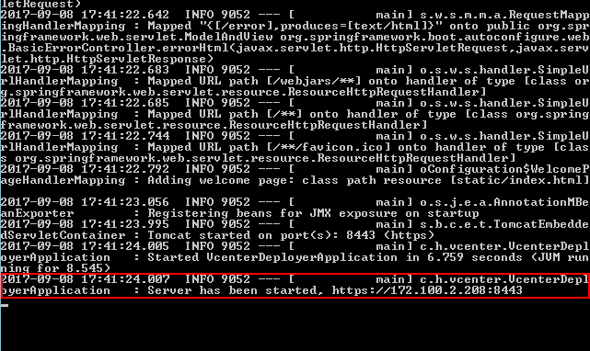

8443 is the default port number. To change the port number, run the following command:
java -jar Deployment program package name.jar --server.port=Customized port number


When you perform the following operations for installing the Huawei vCenter plug-in, do not close the CLI; otherwise, the installation page cannot be opened.
            - Open the browser on the local PC, enter https://vCenter IP address:8443 in the address box, and press Enter.
The Huawei vCenter plugin update program page is displayed, as shown in Figure 1-1.
              - Huawei vCenter plugin update program
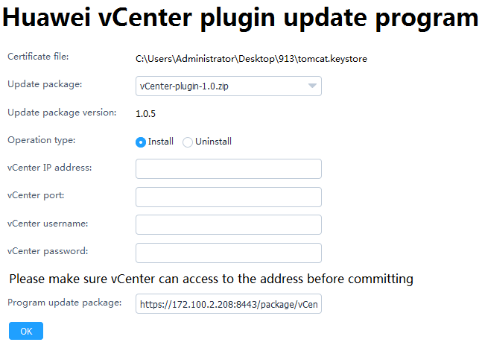

            - Set the following parameters, and click OK.
- Update package: Select the vCenter installation package.
- Operation type: Select Install.
- vCenter IP address: Enter the vCenter IP address.
- vCenter port: Enter the vCenter port number. The default value is 443.
- vCenter username: Enter the vCenter administrator user name.
- vCenter password: Enter the vCenter administrator password.
            - In the vCenter server CLI, view the command output. If information shown in Figure 1-1 is displayed, the Huawei vCenter plug-in is successfully installed.
              - Command output
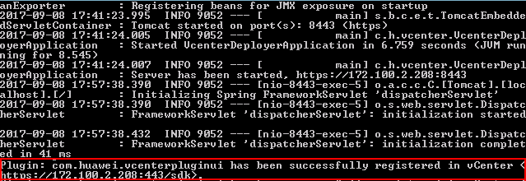

            - Open the browser on the local PC, enter https://vCenter IP address in the address box, and press Enter.
The vCenter login page is displayed.
            - Enter the user name and password for logging in to vCenter, and click Login.
The vCenter homepage is displayed.
If the icon in the red box shown in Figure 1-1 is displayed, the Huawei vCenter plug-in is successfully installed.
              - Homepage
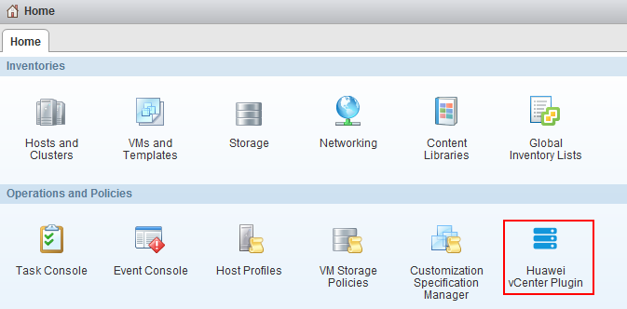

----End

Uninstalling the Huawei vCenter Plug-in
Prerequisites
- JDK 1.8.0 or later has been installed on the vCenter server.
- You have obtained the Huawei deployment program package vcenter-deployer-1.0.jar.
Procedure
            - Log in to the vCenter server as the administrator, and upload the Huawei deployment program package to the vCenter server.
            - Modify the Java environment variable.
Windows Server 2012 R2 is used as an example.
- In Control Panel, choose System and Security > System > Advanced system settings.
The System Properties dialog box is displayed.
- On the Advanced tab, click Environment Variables, as shown in Figure 1-1.
              - System Properties

The Environment Variables dialog box is displayed.
- In the System variables area, select the Path variable, and click Edit.
The Edit System Variable dialog box is displayed.
- Add a variable value, and click OK.
For example, add C:\Program Files\Java\jre1.8.0_121\bin to Variable value, as shown in Figure 1-2.
              - Edit System Variable

- Click OK.
- Click Apply, and click OK.
- Run CMD to access the CLI, and enter java -version to view the JRE version.
            - Decompress the deployment program package.
            - Run CMD to access the CLI, and run the following command to go to the path for storing the deployment program package:
cd Path for storing the deployment program package
            - Run the following command to start the deployment program package:
java -jar Deployment program package name.jar
If information shown in Figure 1-1 is displayed, the program deployment is complete.
              - Command output

8443 is the default port number. To change the port number, run the following command:
java -jar Deployment program package name.jar --server.port=Customized port number

When you perform the following operations for uninstalling the Huawei vCenter plug-in, do not close the CLI; otherwise, the uninstallation page cannot be opened.
            - Open the browser on the local PC, enter https://vCenter IP address:8443 in the address box, and press Enter.
The Huawei vCenter plugin update program page is displayed, as shown in Figure 1-1.
              - Huawei vCenter plugin update program
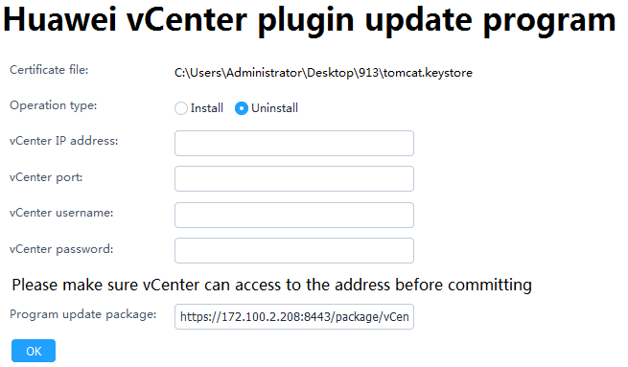

            - Set the following parameters, and click OK.
- Operation type: Select Uninstall.
- vCenter IP address: Enter the vCenter IP address.
- vCenter port: Enter the vCenter port number. The default value is 443.
- vCenter username: Enter the vCenter administrator user name.
- vCenter password: Enter the vCenter administrator password.
            - In the vCenter server CLI, view the command output. If information shown in Figure 1-1 is displayed, the Huawei vCenter plug-in is successfully uninstalled.
              - Command output
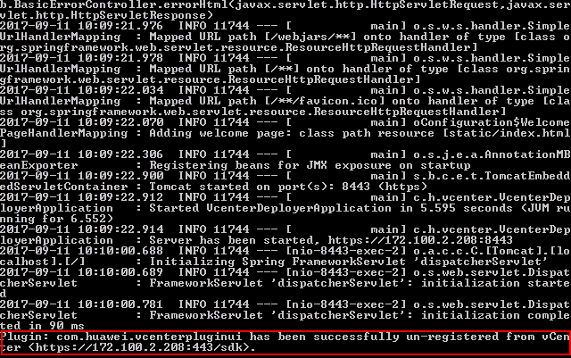

            - Open the browser on the local PC, enter https://vCenter IP address in the address box, and press Enter.
The vCenter login page is displayed.
            - Enter the user name and password for logging in to vCenter, and click Login.
On the vCenter homepage, check whether the plug-in icon is deleted.
- If yes, no further action is required.
- If no, perform Step 11 and Step 12 to clear the browser cache and open the browser again.
            - Clear the browser cache.
Internet Explorer 11.0 is used as an example.
- Select Internet Options.
The Internet Options dialog box is displayed.
- Click Delete, as shown in Figure 1-1.
              - Internet Options
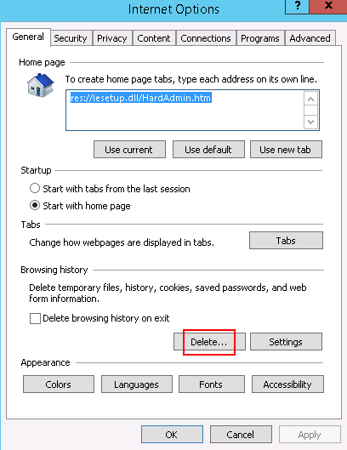

The Delete Browsing History dialog box is displayed.
- Select the required items, and click Delete, as shown in Figure 1-2.
              - Delete Browsing History
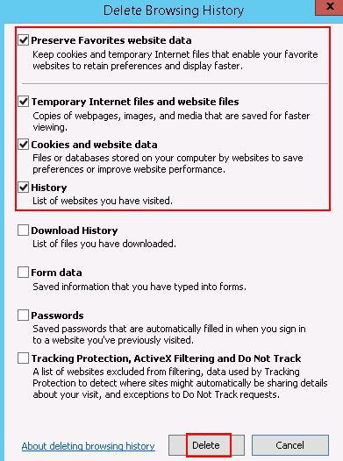

- Click Apply, and click OK.
            - Open the browser again, log in to vCenter, and check whether the plug-in icon is deleted.
- If yes, no further action is required.
- If no, contact Huawei technical support.
----End

Operation and Maintenance

Configuring eSight

Adding eSight
            - Set a whitelist.
By default, a whitelist of eSight northbound ports is configured. To add an eSight system properly, you must add the IP address of the server where vCenter is located to the whitelist of eSight northbound ports.
- Log in to the eSight WebUI.
- Choose System > Northbound Integration > Third-party System > Create.
The Third-party System page is displayed, as shown in Figure 1-1.
              - Third-party System
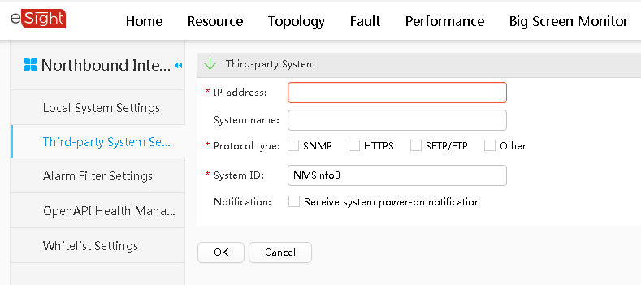

- Set the following parameters:
- IP address: Set this parameter to the IP address of the vCenter server.
- Protocol type: Select HTTPS.
- System ID: Retain the default value or enter a new value. The value can be an IP address or a string of 1 to 64 characters, including digits (0-9), lowercase letters (a-z), uppercase letters (A-Z), and special characters @_- (), .^$~`!.
- Click OK.
The IP address of the vCenter server is set as a whitelist, as shown in Figure 1-2.
              - Set successfully
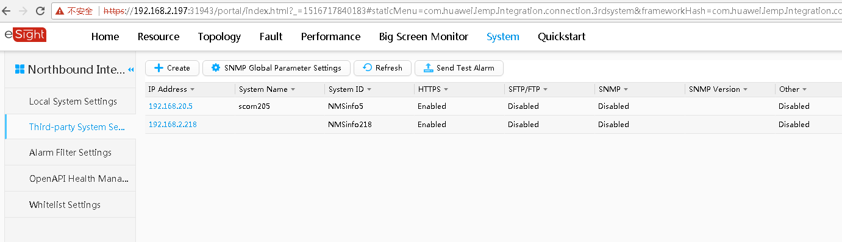

            - On the vCenter WebUI, choose Home > Operations and Policies > Huawei vCenter Plugin.
The Huawei vCenter Plugin page is displayed.
            - Select eSight Set.
The eSight Set page is displayed.
            - Click Add eSight.
The Add eSight dialog box is displayed.
            - Set the following parameters, and click Test, as shown in Figure 1-1.
              - Add eSight
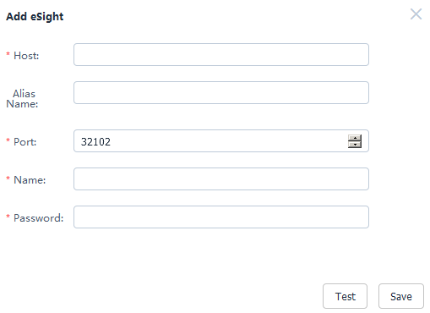

- Host: Enter the IP address of the eSight to be added.
- Alias Name: (Optional) Enter the customized name of the eSight to be added. This name is used to identify the eSight.
- Port: Enter the port number of the eSight to be added.
- Name: Enter the user name of the eSight to be added. The default user name is openApiUser.
- Password: Enter the password of the eSight to be added. The default password is Huawei12#$.
If the connection is successful, "Link test successfully" is displayed on the page. If the connection fails, "Link test failed: An error occurred when connecting to the eSight server." is displayed on the page. Modify parameters according to the error code, and test the connection again.
            - After the connection is successful, click Save to save the eSight configuration information.
The Prompt dialog box is displayed.
            - Click OK.
The eSight is added.
On the eSight Set page, view the added eSight, as shown in Figure 1-1.
              - eSight Set
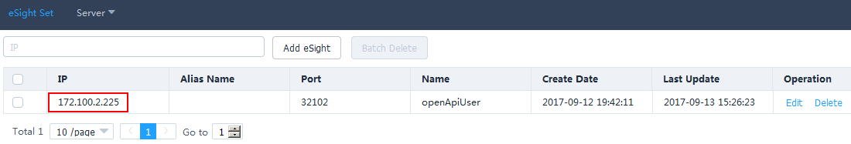

----End

Editing eSight
            - On the vCenter WebUI, choose Home > Operations and Policies > Huawei vCenter Plugin.
The Huawei vCenter Plugin page is displayed.
            - Select eSight Set.
The eSight Set page is displayed.
            - In the row of the eSight to be edited, click Edit.
The Edit eSight dialog box is displayed.
            - Edit the following parameters, as shown in Figure 1-1.
              - Edit eSight
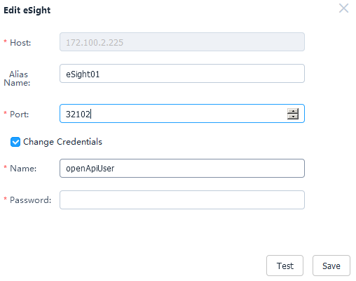

- Alias Name: Change the value to another one. This name is used to identify the eSight.
- Port: Change the eSight port number.
- Change Credentials: This parameter is deselected by default. You can change the eSight user name and password after this parameter is selected.
- Name: Change the eSight user name. The default user name is openApiUser.
- Password: Change the eSight password. The default password is Huawei12#$.
After eSight is accessed, if the eSight port number, user name, or password is changed, you must synchronize the new port number, user name, or password to the Huawei vCenter plug-in; otherwise, server management of the Huawei vCenter plug-in will be affected.
            - Check whether Change Credentials is selected and the user name or password is changed.
- If yes, click Test. After the connection is successful, click Save to save the eSight configuration information.
- If no, click Save to save the eSight configuration information.
The Prompt dialog box is displayed.
            - Click OK.
The eSight is edited.
On the eSight Set page, view the modified eSight, as shown in Figure 1-1.
              - eSight Set
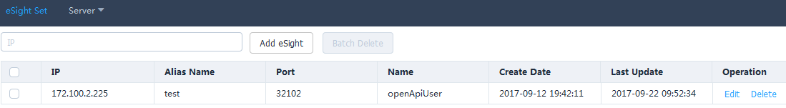

----End

Deleting eSight
            - On the vCenter WebUI, choose Home > Operations and Policies > Huawei vCenter Plugin.
The Huawei vCenter Plugin page is displayed.
            - Select eSight Set.
The eSight Set page is displayed.
            - In the row of the eSight to be deleted, click Delete, as shown in Figure 1-1.
              - Deleting eSight
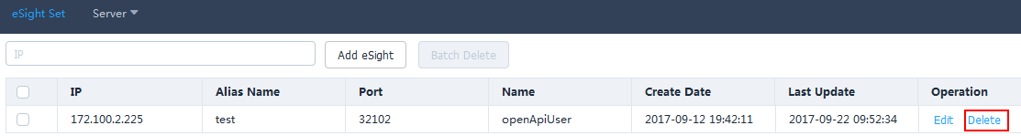

The Prompt dialog box is displayed.
To delete eSight systems in batches, select the eSight systems to be deleted, and click Batch Delete.
            - Click OK.
The eSight is deleted.
----End

Managing Servers

Viewing the Server List
            - On the vCenter WebUI, choose Home > Operations and Policies > Huawei vCenter Plugin.
The Huawei vCenter Plugin page is displayed.
            - Choose Server > Server List.
The Server List page is displayed.
            - Select eSight Alias Name and Server Type, and view the values of IP Address, Name, Status, and Model of the selected server type under the eSight, as shown in Figure 1-1.
              - Server list
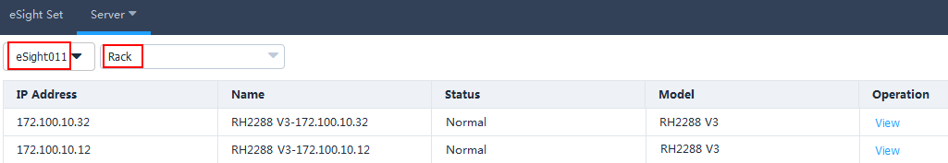

            - In the row of any server, click View.
View the basic information, online device status, and mainboard, CPU, memory, hard disk, PSU, fan, RAID, NIC, and PCIe information of the server, as shown in Figure 1-1.
              - Device status
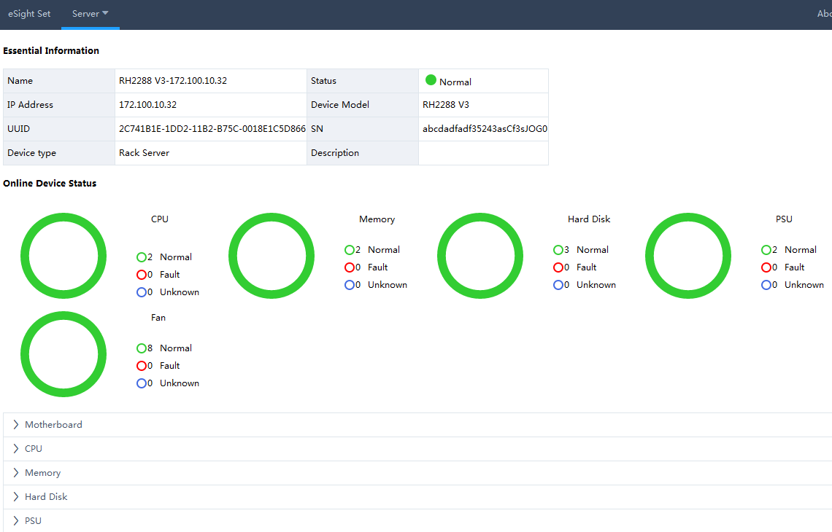

            - Click Back.
The Server List page is displayed.
----End

Deploying an OS

Adding a Software Source
            - Upload the OS image file to be added to the Secure File Transfer Protocol (SFTP) server.
            - On the vCenter WebUI, choose Home > Operations and Policies > Huawei vCenter Plugin.
The Huawei vCenter Plugin page is displayed.
            - Choose Server > Software Source Management.
The Software Source Management page is displayed.
            - Click Add.
The Add Software Source dialog box is displayed.
            - Set the following parameters, and click OK, as shown in Figure 1-1.
              - Add Software Source
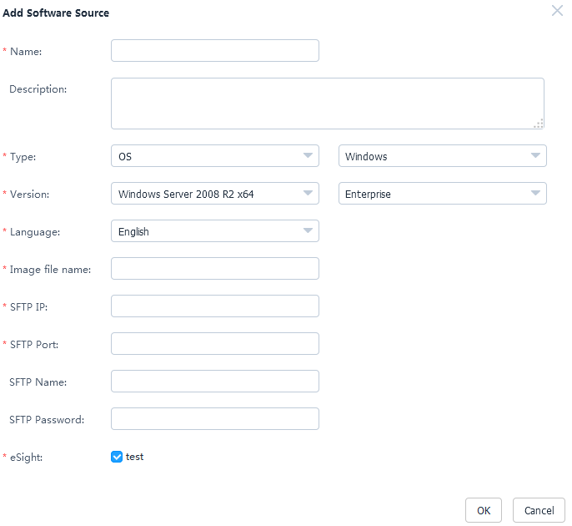

- Name: Set this parameter to a customized name. This parameter is used to identify the OS image file.
- Description: (Optional) Set this parameter to the customized description of the OS image file.
- Type: Select an OS type. The OS types include Windows, SUSE, Red Hat, CentOS, Ubuntu, and VMware ESXi.
- Version: Select an OS version.
- Language: Select a language. This parameter needs to be set only when the OS type is Windows. Select Chinese or English.
- Image file name: Enter the name of the image file on the SFTP server.
- SFTP IP: Enter the SFTP server IP address.
- SFTP Port: Enter the SFTP server port number.
- SFTP Name: Enter the SFTP server user name.
- SFTP Password: Enter the SFTP server password.
- eSight: Select the eSight of the OS image file to be added. You can select multiple eSight systems at the same time.
The Prompt dialog box is displayed.
            - Click OK.
The software source is added.
On the Software Source Management page, view the added software source, as shown in Figure 1-1.
              - Software Source Management
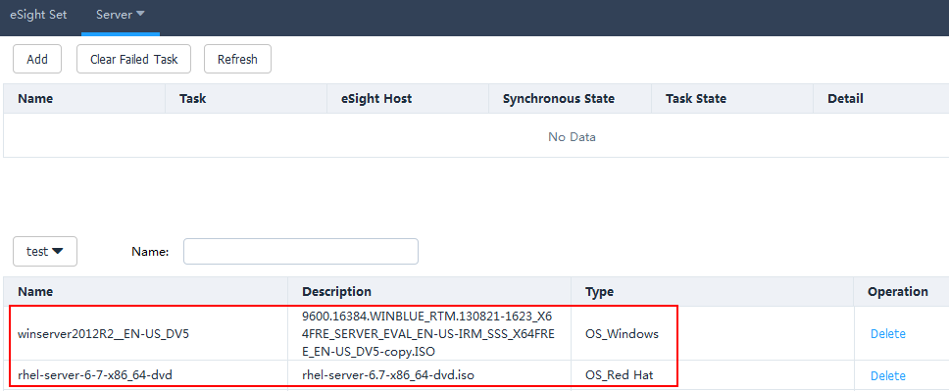

- Click Refresh to view the software source uploading progress.
- To delete a software source that fails to be uploaded, click Clear Failed Task. All software sources that fail to be uploaded will be deleted.
- To delete a software source that is successfully uploaded, click Delete in the row of the software source to be deleted.
----End

Creating an OS Template
            - On the vCenter WebUI, choose Home > Operations and Policies > Huawei vCenter Plugin.
The Huawei vCenter Plugin page is displayed.
            - Choose Server > Template Management.
The Template Management page is displayed.
            - Click Create Template.
The page for creating a template is displayed.
            - Set the following parameters, as shown in Figure 1-1.
              - Creating an OS template
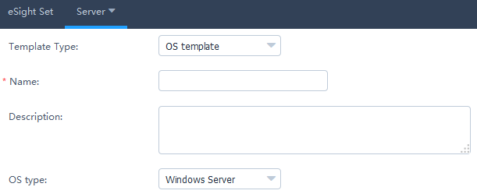

- Template Type: Select OS template.
- Name: Set this parameter to a customized name. This parameter is used to identify the OS template.
- Description: (Optional) Set this parameter to customized description, which provides supplementary information for the OS template.
- OS type: Select the required OS type.
            - In the OS Settings area, set the following parameters, as shown in Figure 1-1.
              - OS Settings
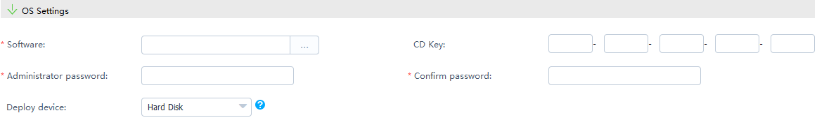

- Software: Select the added software source.
- CD Key: Enter the OS serial number. This parameter needs to be set only when the OS type is Windows Server.
- Administrator password: Enter the OS administrator password.
- Confirm password: Enter the OS administrator password again.
- Deploy device: Select the deployment device based on the actual requirements.
- If the OS type is VMware ESXi 5.0, the deployment device is Hard Disk.
- If the OS type is VMware ESXi 5.1/5.5/6.0, the deployment device is Hard Disk or USB device.
            - Set Partition Settings only when the OS type is Windows Server/SUSE Linux/Red Hat/CentOS, as shown in Figure 1-1.
              - Partition Settings
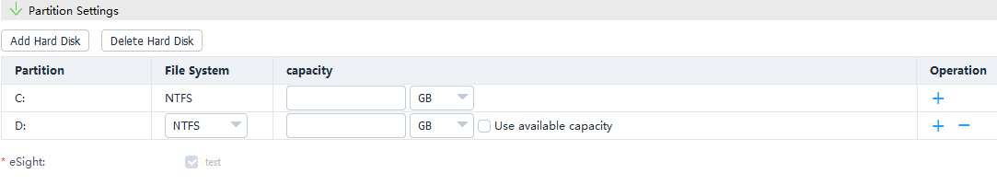

- Click Add Hard Disk.
- Set File System, enter the capacity of the new hard disk, and determine whether to use the remaining capacity based on the actual requirements.
- To add a hard disk partition, click .
- To delete a hard disk partition, click .
- To delete a hard disk, click Delete Hard Disk.
            - Click OK.
The Prompt dialog box is displayed.
            - Click OK.
The OS template is created.
On the Template Management page, view the created OS template, as shown in Figure 1-1.
              - Template Management
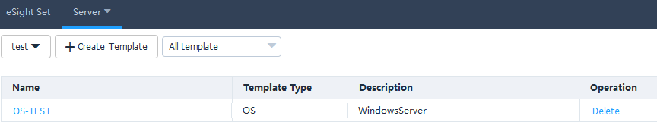

To delete a template, click Delete in the row of the template to be deleted.
----End

Creating a Template Task
            - On the vCenter WebUI, choose Home > Operations and Policies > Huawei vCenter Plugin.
The Huawei vCenter Plugin page is displayed.
            - Choose Server > Task Management.
The Task Management page is displayed.
            - Click Create Task.
The page for adding a task is displayed.
            - Set the following parameters, and click OK, as shown in Figure 1-1.
              - Creating a task
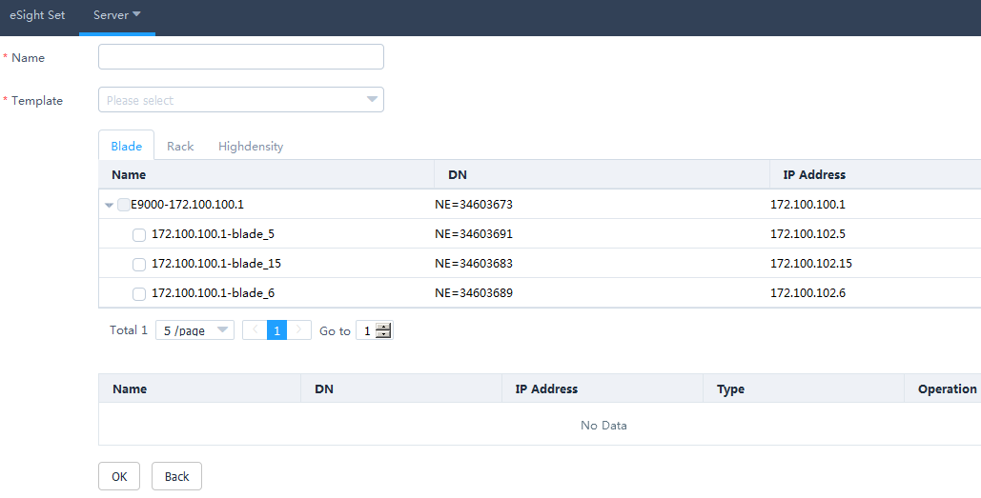

- Name: Set this parameter to a customized task name. This parameter is used to identify the task.
- Template: Select a created template, and select the server to be added to the template.
The Prompt dialog box is displayed.
            - Click OK.
The task is created.
On the Task Management page, view the created task, as shown in Figure 1-1.
              - Task Management
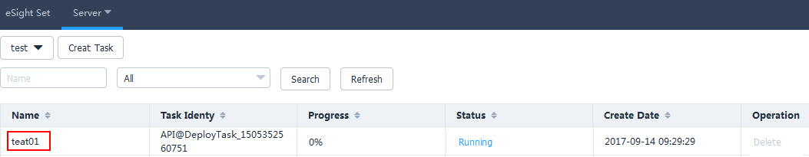

When the value of Progress changes to 100%, click Status value in Status, and view the template task execution result, as shown in Figure 1-2.
              - Details about Deployed Devices
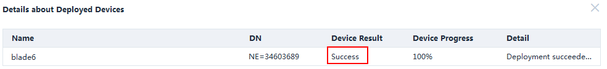

- Click Refresh to view the template task progress.
- To delete a template task, click Delete in the row of the template task to be deleted.
----End

Managing Templates

Configuring Power Control
            - On the vCenter WebUI, choose Home > Operations and Policies > Huawei vCenter Plugin.
The Huawei vCenter Plugin page is displayed.
            - Choose Server > Template Management.
The Template Management page is displayed.
            - Click Create Template.
The page for creating a template is displayed.
            - Set the following parameters, and click OK, as shown in Figure 1-1.
              - Adding a power control template
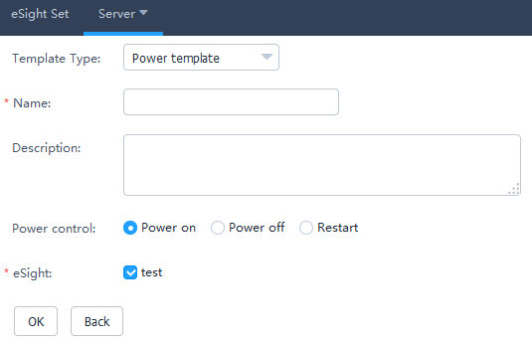

- Template Type: Select Power template.
- Name: Set this parameter to a customized name. This parameter is used to identify the power control template.
- Description: (Optional) Set this parameter to customized description, which provides supplementary information for the power control template.
- Power control: Select Power on, Power off, or Restart.
- eSight: Select the eSight based on the actual requirements. You can select multiple eSight systems.
The Prompt dialog box is displayed.
            - Click OK.
The power control template is created.
On the Template Management page, view the created power control template.
To delete a template, click Delete in the row of the template to be deleted.
            - Create a template task. For details, see 3.2.2.3 Creating a Template Task.
----End

Configuring the BIOS
            - On the vCenter WebUI, choose Home > Operations and Policies > Huawei vCenter Plugin.
The Huawei vCenter Plugin page is displayed.
            - Choose Server > Template Management.
The Template Management page is displayed.
            - Click Create Template.
The page for creating a template is displayed.
            - Set the following parameters, as shown in Figure 1-1.
              - Adding a BIOS template
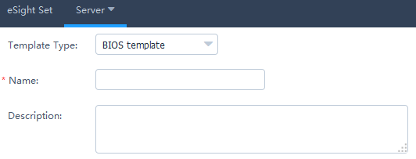

- Template Type: Select BIOS template.
- Name: Set this parameter to a customized name. This parameter is used to identify the BIOS template.
- Description: (Optional) Set this parameter to customized description, which provides supplementary information for the BIOS template.
            - In the Boot area, use or to set the system boot sequence.
            - In the Virtualization area, set the parameters described in Table 1-1, as shown in Figure 1-1.
              - Virtualization

                - Parameters in the Virtualization area
Parameter | Description
VT support | Enables or disables the hardware-assisted virtualization technology.  - Enabled: enables the hardware-assisted virtualization technology.  - Disabled: disables the hardware-assisted virtualization technology.  - Default: retains the default settings.
PCIe SR-IOV | Enables or disables the SR-IOV technology of the PCIe card.  - Enabled: enables the SR-IOV technology of the PCIe card.  - Disabled: disables the SR-IOV technology of the PCIe card.  - Default: retains the default settings.

            - In the Advanced Processor area, set the parameters described in Table 1-1, as shown in Figure 1-1.
              - Advanced Processor
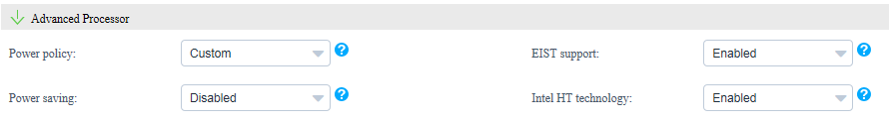

                - Parameters in the Advanced Processor area
Parameter | Description
Power policy | Indicates the power policy.  - Efficient: indicates the mode of low performance and low power consumption. This mode can reduce the power consumption of the system.  - Performance: indicates the mode of high performance and high power consumption.  - Custom: indicates the mode that reduces the power consumption of most OSs and applications and minimizes the impact on performance.  - Default: retains the default settings.
EIST support | Indicates the intelligent frequency control function.  - Enabled: enables the EIST function.  - Disabled: disables the EIST function.  - Default: retains the default settings.
Power saving | Indicates the CPU P State adjustment function.  - Enabled: enables the CPU P State adjustment function.  - Disabled: disables the CPU P State adjustment function.  - Default: retains the default settings.
Intel HT technology | Indicates the Intel Hyper Threading (HT) technology. This technology enhances CPU performance by increasing the number of CPU kernel threads.  - Enabled: enables the CPU HT function.  - Disabled: disables the CPU HT function.  - Default: retains the default settings.

            - In the IPMI area, set the parameters described in Table 1-1, as shown in Figure 1-1.
              - IPMI

                - Parameters in the IPMI area
Parameter | Description
Restore on AC Power Loss | Indicates the restoration mode used by the BMC after AC power-off.  - Power OFF: powers off the system.  - Last State: restores the system to the last state.  - Power ON: powers on the system.  - Default: retains the default settings.

            - Click Advanced.
The Advanced Settings dialog box is displayed.
            - In the Boot area, set the parameters described in Table 1-1, as shown in Figure 1-1.
              - Boot
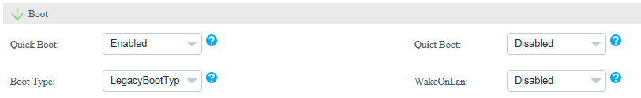

                - Parameters in the Boot area
Parameter | Description
Quick Boot | Indicates the quick boot mode.  - Enabled: enables the quick boot mode.  - Disabled: disables the quick boot mode.  - Default: retains the default settings.
Quiet Boot | Indicates the quiet boot mode.  - Enabled: enables the quiet boot mode.  - Disabled: disables the quiet boot mode.  - Default: retains the default settings.
Boot Type | Indicates the system boot mode.  - Dual Boot Type: supports both the Legacy boot mode and the UEFI boot mode.  - Legacy Boot Type: supports only the Legacy boot mode.  - UEFI Boot Type: supports only the UEFI boot mode.  - Default: retains the default settings.
WakeOnLan | Indicates the remote startup of a server when it receives a special data packet.  - Enabled: enables the Wake On Lan function.  - Disabled: disables the Wake On Lan function.  - Default: retains the default settings.

            - In the Virtualization area, set the parameters described in Table 1-1, as shown in Figure 1-1.
              - Virtualization
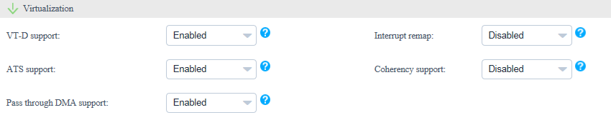

                - Parameters in the Virtualization area
Parameter | Description
VT-D support | Indicates the direct I/O virtualization function.  - Enabled: enables the direct I/O virtualization function.  - Disabled: disables the direct I/O virtualization function.  - Default: retains the default settings.
Interrupt remap | Indicates the interrupt remapping function.  - Enabled: enables the interrupt remapping function.  - Disabled: disables the interrupt remapping function.  - Default: retains the default settings.
ATS support | Indicates the ATS function.  - Enabled: enables the ATS function.  - Disabled: disables the ATS function.  - Default: retains the default settings.
Coherency support | Indicates the Coherency Support function.  - Enabled: enables the Coherency Support function.  - Disabled: disables the Coherency Support function.  - Default: retains the default settings.
Pass through DMA support | Indicates the PassThrough DMA function.  - Enabled: enables the PassThrough DMA function.  - Disabled: disables the PassThrough DMA function.  - Default: retains the default settings.

            - In the Advanced Processor area, set the parameters described in Table 1-1, as shown in Figure 1-1.
              - Advanced Processor
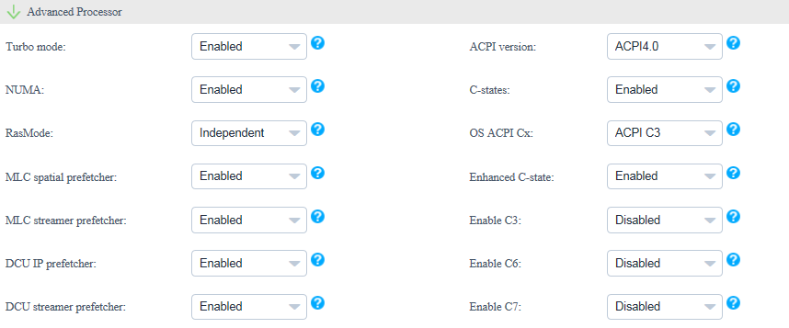

                - Parameters in the Advanced Processor area
Parameter | Description
Turbo mode | Indicates the dynamic acceleration function.  - Enabled: enables the dynamic acceleration function.  - Disabled: disables the dynamic acceleration function.  - Default: retains the default settings.
ACPI version | Indicates the ACPI version.  - ACPI1.0B: ACPI1.0B version  - ACPI3.0: ACPI3.0 version  - ACPI4.0: ACPI4.0 version  - Default: retains the default settings.
NUMA | Indicates the non-uniform memory access (NUMA) function.  - Enabled: enables the NUMA function.  - Disabled: disables the NUMA function.  - Default: retains the default settings.
C-states | Indicates the CPU C status control function.  - Enabled: enables the CPU C status control function.  - Disabled: disables the CPU C status control function.  - Default: retains the default settings.
RasMode | Indicates the memory RAS mode.  - Independent  - Mirror  - LockStep  - RankSpare  - LockStepAndRankSpare  - Default
OS ACPI Cx | Indicates the Advanced Configuration and Power Interface (ACPI) C-state of the OS. The OS instructs a CPU to enter the C-state based on the ACPI C-state.  - ACPI C2  - ACPI C3  - Default
MLC spatial prefetcher | Indicates the Mid Level Cache (MLC) Spatial prefetcher function.  - Enabled: enables the MLC Spatial prefetcher function.  - Disabled: disables the MLC Spatial prefetcher function.  - Default: retains the default settings.
Enhanced C-state | Indicates the C-state function.  - Enabled: enables the C-state function.  - Disabled: disables the C-state function.  - Default: retains the default settings.
MLC streamer prefetcher | Indicates the MLC Streamer prefetcher function.  - Enabled: enables the MLC Streamer prefetcher function.  - Disabled: disables the MLC Streamer prefetcher function.  - Default: retains the default settings.
Enable C3 | Indicates the C3 function.  - Enabled: enables the C3 function.  - Disabled: disables the C3 function.  - Default: retains the default settings.
DCU IP prefetcher | Indicates the data cache unit (DCU) IP prefetcher function. This function determines whether to prefetch data based on historical records. This function is enabled by default. You can enable or disable this function based on the applications running on the server. This function can affect performance and shorten the data reading time.  - Enabled: enables the DCU IP prefetcher function.  - Disabled: disables the DCU IP prefetcher function.  - Default: retains the default settings.
Enable C6 | Indicates the C6 function.  - Enabled: enables the C6 function.  - Disabled: disables the C6 function.  - Default: retains the default settings.
DCU streamer prefetcher | Indicates the DCU streamer prefetcher function. This function can be used to preread CPU data. This function is enabled by default. You can enable or disable this function based on the applications running on the server. This function can affect performance and shorten the data reading time.  - Enabled: enables the DCU streamer prefetcher function.  - Disabled: disables the DCU streamer prefetcher function.  - Default: retains the default settings.
Enable C7 | Indicates the C7 function.  - Enabled: enables the C7 function.  - Disabled: disables the C7 function.  - Default: retains the default settings.

            - In the Console Serial Port area, set the parameters described in Table 1-1, as shown in Figure 1-1.
              - Console Serial Port
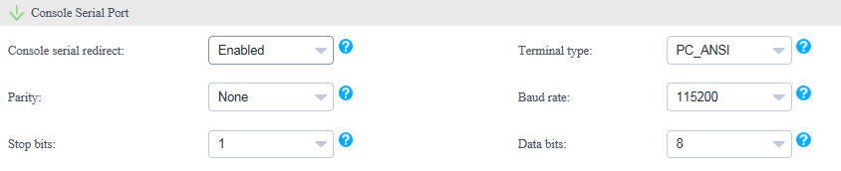

                - Parameters in the Console Serial Port area
Parameter | Description
Console serial redirect | Indicates the serial port redirection function.  - Enabled: enables the serial port redirection function.  - Disabled: disables the serial port redirection function.  - Default: retains the default settings.
Terminal type | Indicates the terminal protocol.  - VT_100  - VT_100+  - VT_UTF8  - PC_ANSI  - Default
Parity | Indicates the parity check function.  - None: indicates no parity check.  - Even: indicates the even parity check.  - Odd: indicates the odd parity check.  - Default: retains the default settings.
Baud rate | Indicates the serial port redirection speed.  - 115200  - 57600  - 19200  - 9600  - Default
Stop bits | Indicates the stop bit for the serial port redirection function.  - 1  - 2  - Default
Data bits | Indicates the data bit length for the serial port redirection function.  - 7  - 8  - Default

            - In the IPMI area, set the parameters described in Table 1-1, as shown in Figure 1-1.
              - IPMI
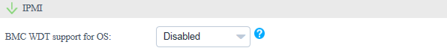

                - Parameters in the IPMI area
Parameter | Description
BMC WDT support for OS | Indicates the watchdog during the OS startup process.  - Enabled: enables the watchdog during the OS startup process.  - Disabled: disables the watchdog during the OS startup process.  - Default: retains the default settings.

            - Click OK.
            - Select the eSight to which the BIOS template is to be added, and click OK. (You can select multiple eSight systems.)
The Prompt dialog box is displayed.
            - Click OK.
The BIOS template is created.
On the Template Management page, view the created BIOS template.
To delete a template, click Delete in the row of the template to be deleted.
            - Create a template task. For details, see 3.2.2.3 Creating a Template Task.
----End

Configuring an HBA
            - On the vCenter WebUI, choose Home > Operations and Policies > Huawei vCenter Plugin.
The Huawei vCenter Plugin page is displayed.
            - Choose Server > Template Management.
The Template Management page is displayed.
            - Click Create Template.
The page for creating a template is displayed.
            - Set the following parameters, as shown in Figure 1-1.
              - Adding an HBA template
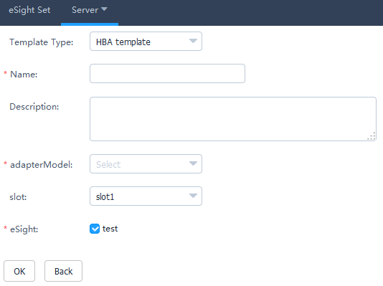

- Template Type: Select HBA template.
- Name: Set this parameter to a customized name. This parameter is used to identify the HBA template.
- Description: (Optional) Set this parameter to customized description, which provides supplementary information for the HBA template.
- Adapter Model: Select the HBA model.
- slot: Select the HBA slot number.
- eSight: Select the eSight based on the actual requirements. You can select multiple eSight systems.
            - In the port area, click Advanced.
The Advanced dialog box is displayed.
            - Set the following parameters, and click OK, as shown in Figure 1-1.
              - Advanced
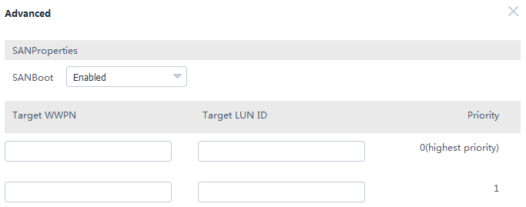

- SAN boot: Select Enabled or Disabled.
- Target WWPN: This parameter needs to be set only when SAN boot is set to Enabled.
- Target LUN ID: This parameter needs to be set only when SAN boot is set to Enabled.
- Target WWNN: This parameter needs to be set only when SAN boot is set to Enabled and Adapter Model is set to QLE2560 or QLE2562.
            - Click OK.
The Prompt dialog box is displayed.
            - Click OK.
The HBA template is created.
On the Template Management page, view the created HBA template.
To delete a template, click Delete in the row of the template to be deleted.
            - Create a template task. For details, see 3.2.2.3 Creating a Template Task.
----End

Configuring RAID
            - On the vCenter WebUI, choose Home > Operations and Policies > Huawei vCenter Plugin.
The Huawei vCenter Plugin page is displayed.
            - Choose Server > Template Management.
The Template Management page is displayed.
            - Click Create Template.
The page for creating a template is displayed.
            - Set the following parameters, as shown in Figure 1-1.
              - Adding a RAID template
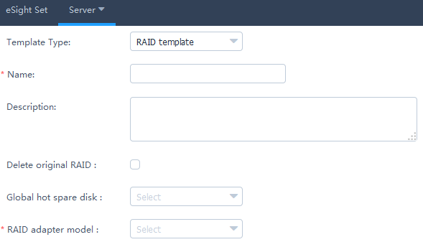

- Template Type: Select RAID template.
- Name: Set this parameter to a customized name. This parameter is used to identify the RAID template.
- Description: (Optional) Set this parameter to customized description, which provides supplementary information for the RAID template.
- Delete original RAID: This parameter is deselected by default. Determine whether to select this parameter based on the actual situation.
- Global hot spare disk: (Optional) This parameter is not set by default. Select the slot number of the hard disk to be set to a global hot spare disk. You can select multiple slot numbers.
- RAID adapter model: Select the model of the RAID adapter to be configured.
            - In the RAID Group area, click Create.
The Create RAID Group dialog box is displayed.
            - Set the following parameters, and click OK, as shown in Figure 1-1.
              - Create RAID Group
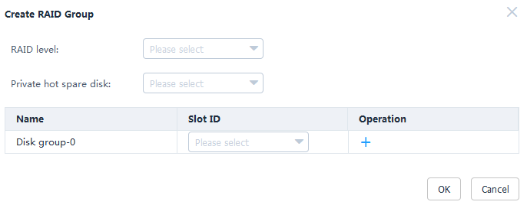

- RAID level: Select the RAID level to be configured.
- Private hot spare disk: (Optional) This parameter is not set by default. Select the slot number of the hard disk to be set to a private hot spare disk. You can select multiple slot numbers.
- Private hot spare disks cannot be configured for RAID 0.
- Private hot spare disks cannot be configured for LSI SAS2308 and LSI SAS3008.
- Disk group-0: Select the slot number of the hard disk to be added to the hard disk group.
Only one disk group can be created for RAID 0, RAID 1, RAID 5, RAID 6, and RAID 1E.
            - (Optional) Retain the default value 0 for Start LUN ID.
            - Click OK.
The Prompt dialog box is displayed.
            - Click OK.
The RAID template is created.
On the Template Management page, view the created RAID template.
To delete a template, click Delete in the row of the template to be deleted.
            - Create a template task. For details, see 3.2.2.3 Creating a Template Task.
----End

Configuring a CNA
            - On the vCenter WebUI, choose Home > Operations and Policies > Huawei vCenter Plugin.
The Huawei vCenter Plugin page is displayed.
            - Choose Server > Template Management.
The Template Management page is displayed.
            - Click Create Template.
The page for creating a template is displayed.
            - Set the following parameters, as shown in Figure 1-1.
              - Adding a CNA template
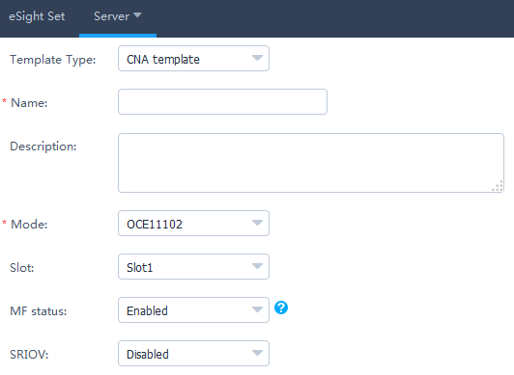

- Template Type: Select CNA template.
- Name: Set this parameter to a customized name. This parameter is used to identify the CNA template.
- Description: (Optional) Set this parameter to customized description, which provides supplementary information for the CNA template.
- Mode: Select the CNA model.
- Slot: (Optional) Select the CNA slot number.
- MF status: (Optional) This parameter needs to be set only when Mode is set to OCE11102, MZ510, or MZ512. Determine whether to enable MF based on the actual situation.
- SRIOV: (Optional) This parameter needs to be set only when Mode is set to OCE11102, MZ510, or MZ512. Determine whether to enable SRIOV based on the actual situation.
MF and SRIOV cannot be enabled at the same time.
            - Check whether Mode is set to MZ910.
- If yes, perform Step 6 and Step 7.
- If no, go to Step 8.
            - In the port area, click Advanced.
The Advanced dialog box is displayed.
            - Enable or disable PXE boot, and click OK.
Then go to Step 11.
            - In the port area, set the parameters described in Table 1-1.
                - Port0
Parameter | Description
PF type | - NIC  - iSCSI  - FCoE  NOTE  iSCSI and FCoE are available only for PF1.
PF VLAN ID | This parameter needs to be set if PF type is set to NIC. Enter a VLAN ID based on the actual situation.

            - In the port area, click Advanced.
The Advanced dialog box is displayed.
            - Set the parameters described in Table 1-1, as shown in Figure 1-1.
              - Advanced
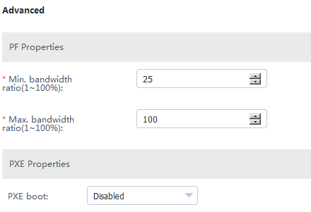

                - Parameters in the Advanced dialog box
Parameter | Description
Min. bandwidth ratio | Indicates the minimum bandwidth ratio of a single virtual network port.
Max. bandwidth ratio | Indicates the maximum bandwidth ratio of a single virtual network port.
PXE boot | This parameter can be set to Enabled or Disabled.

            - Click OK.
The Prompt dialog box is displayed.
            - Click OK.
The CNA template is created.
On the Template Management page, view the created CNA template.
To delete a template, click Delete in the row of the template to be deleted.
            - Create a template task. For details, see 3.2.2.3 Creating a Template Task.
----End

Configuring the iBMC
            - On the vCenter WebUI, choose Home > Operations and Policies > Huawei vCenter Plugin.
The Huawei vCenter Plugin page is displayed.
            - Choose Server > Template Management.
The Template Management page is displayed.
            - Click Create Template.
The page for creating a template is displayed.
            - Set the following parameters, as shown in Figure 1-1.
              - Adding an iBMC template
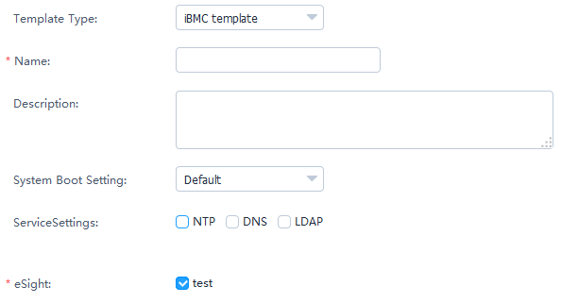

- Template Type: Select iBMC template.
- Name: Set this parameter to a customized name. This parameter is used to identify the iBMC template.
- Description: (Optional) Set this parameter to customized description, which provides supplementary information for the iBMC template.
- System Boot Setting: Select a system boot option based on the actual situation.
- Service Settings: Select a service setting option based on the actual situation. You can select multiple options. After NTP, DNS, or LDAP is selected, the related parameters need to be set.
- eSight: Select the eSight based on the actual requirements. You can select multiple eSight systems.
            - In the NTP area, set the parameters described in Table 1-1, as shown in Figure 1-1.
              - NTP
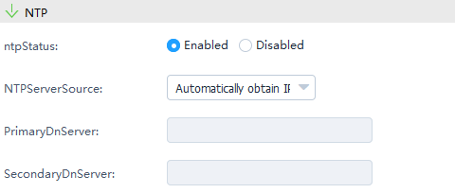

                - Parameters in the NTP area
Parameter | Description
NTP Status | Enable or disable NTP.  - Enabled  - Disabled
NTP Server Source | Select the NTP server source obtaining mode.  - Automatically obtain IPv4  - Automatically obtain IPv6  - Manually obtain
Primary NTP Server | (Optional) Enter the preferred NTP server IP address only when the NTP server source is obtained manually.
Secondary NTP Server | (Optional) Enter the alternate NTP server IP address only when the NTP server source is obtained manually.

            - In the DNS area, set the parameters described in Table 1-1.
                - Parameters in the DNS area
Parameter | Description
DNS Source | Select the DNS obtaining mode.  - Automatically Obtain  - Manually Set
Domain Name | (Optional) Set the domain name only when the DNS is set manually.
Primary DNS Server | (Optional) Set the preferred DNS server IP address only when the DNS is set manually.
Secondary DNS Server | (Optional) Set the alternate DNS server IP address only when the DNS is set manually.

            - In the LDAP area, set the parameters described in Table 1-1, as shown in Figure 1-1.
              - LDAP
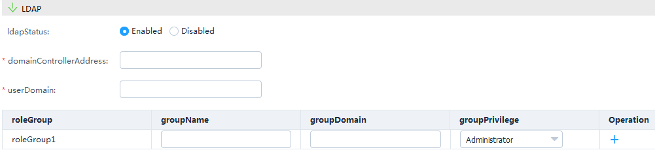

                - Parameters in the LDAP area
Parameter | Description
LDAP Status | Select the LDAP status.  - Enabled  - Disabled
Domain Controller Address | (Optional) Set the domain controller address only when LDAP is enabled.
User Domain | (Optional) Set the user domain only when LDAP is enabled.
Role Group | (Optional) Set the group name, group domain, and group privilege only when LDAP is enabled.  NOTE  You need to configure at least one role group. A maximum of five role groups can be configured.

            - Click OK.
The Prompt dialog box is displayed.
            - Click OK.
The iBMC template is created.
On the Template Management page, view the created iBMC template.
To delete a template, click Delete in the row of the template to be deleted.
            - Create a template task. For details, see 3.2.2.3 Creating a Template Task.
----End

Upgrading the Firmware and Driver

Uploading an Upgrade Package
            - Upload an upgrade package file to the SFTP server.
            - On the vCenter WebUI, choose Home > Operations and Policies > Huawei vCenter Plugin.
The Huawei vCenter Plugin page is displayed.
            - Choose Server > Firmware Upload.
The Firmware Upload page is displayed.
            - Click Add.
The page for adding a file is displayed.
            - Set the following parameters, and click OK, as shown in Figure 1-1.
              - Uploading an upgrade package
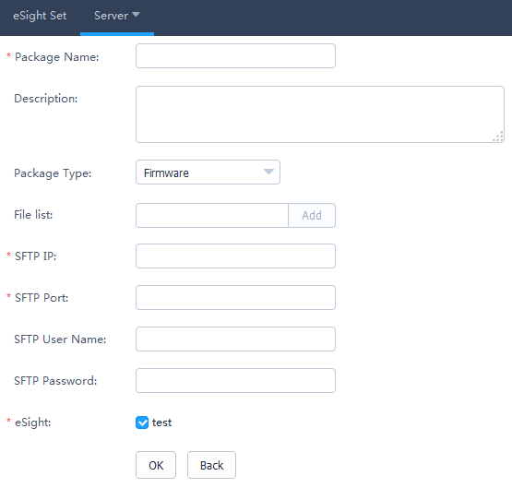

- Package Name: Set this parameter to a customized upgrade package name. This parameter is used to identify the upgrade package.
- Description: Set this parameter to customized description, which provides supplementary information for the upgrade package.
- Package Type: Select Firmware, Driver, or Bundle.
- File list: Click Add, and select the upgrade package file.
You need to upload the ZIP package and digital signature certificate if Package Type is set to Firmware or Driver. You need to upload only the ZIP package if Package Type is set to Bundle.
- SFTP IP: Enter the SFTP server IP address.
- SFTP Port: Enter the SFTP server port number.
- SFTP User Name: Enter the SFTP server user name.
- SFTP Password: Enter the SFTP server password.
- eSight: Select the eSight based on the actual requirements. You can select multiple eSight systems.
The Prompt dialog box is displayed.
            - Click OK.
The firmware uploading task is created.
On the Firmware Upload page, view the created firmware uploading task, as shown in Figure 1-1.
              - Firmware Upload
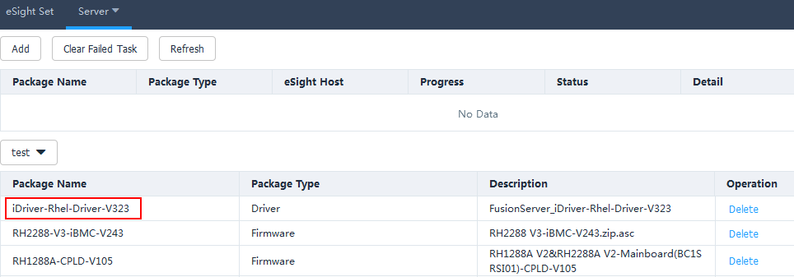

- Click Refresh to view the firmware uploading progress.
- When the value of Progress changes to 100%, view Status value in Status to check whether the upgrade package is successfully uploaded.
- To delete an upgrade package that fails to be uploaded, click Clear Failed Task. All upgrade packages that fail to be uploaded will be deleted.
- To delete an upgrade package that is successfully uploaded, click Delete in the row of the upgrade package to be deleted.
----End

Upgrading the Firmware and Driver
            - On the vCenter WebUI, choose Home > Operations and Policies > Huawei vCenter Plugin.
The Huawei vCenter Plugin page is displayed.
            - Choose Server > Firmware Upgrade.
The Firmware Upgrade page is displayed.
            - Click Create Task.
The page for adding a task is displayed.
            - Set the following information, and click OK, as shown in Figure 1-1.
              - Creating an upgrade task
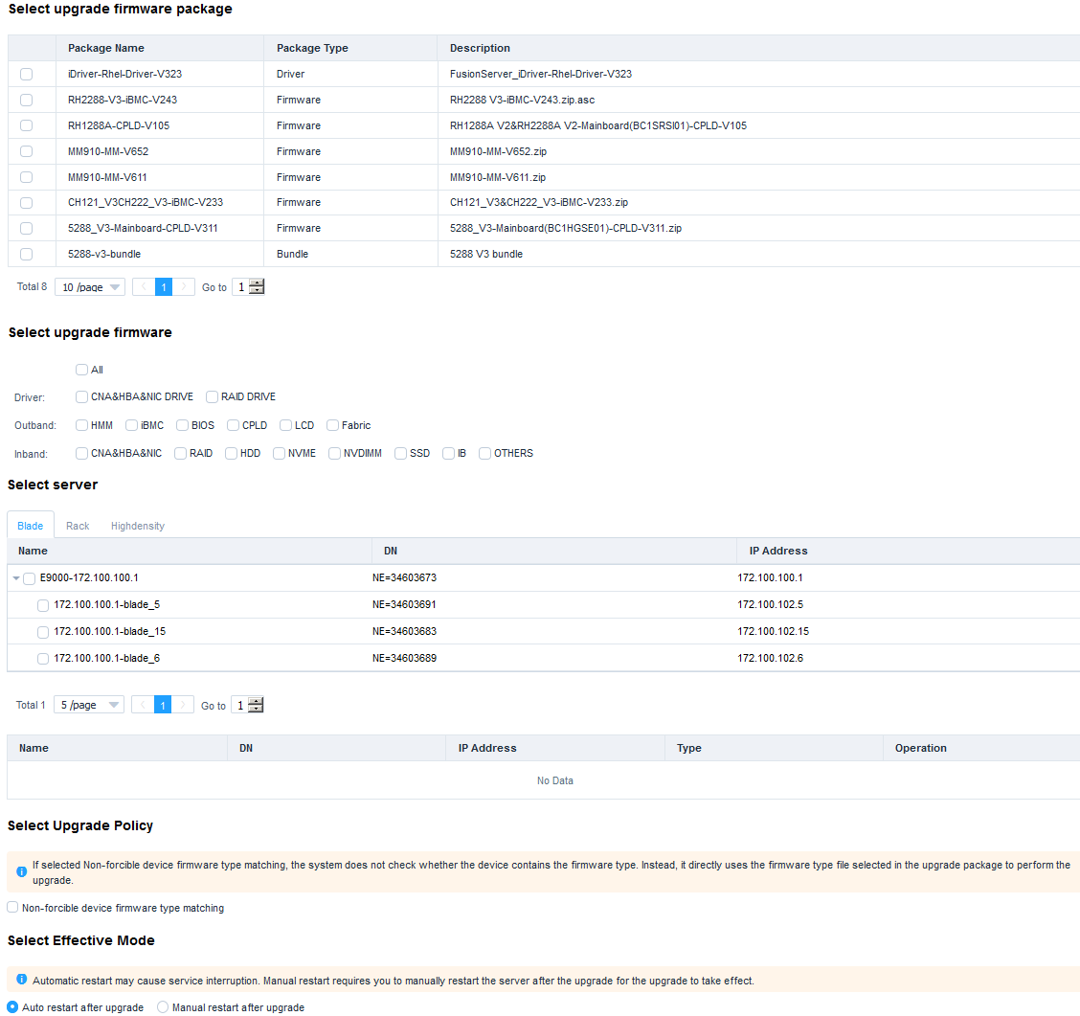

- Select upgrade firmware package: Select the name of the firmware package to be upgraded.
- Select upgrade firmware: Select the firmware to be upgraded.
- Select server: Select the server to be upgraded.
- Select Upgrade Policy: Non-forcible device firmware type matching is deselected by default.
- Select Effective Mode: Auto restart after upgrade is selected by default.
The Prompt dialog box is displayed.
            - Click OK.
The upgrade task is created.
On the Firmware Upgrade page, view the created firmware upgrade task, as shown in Figure 1-1.
              - Firmware Upgrade
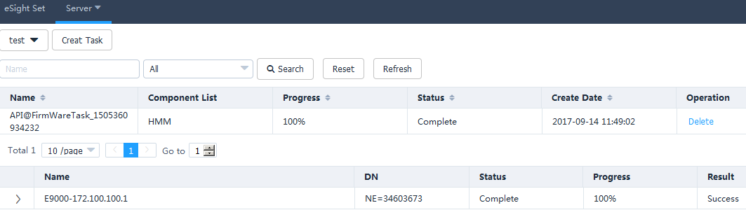

- Click Refresh to view the firmware and driver upgrade progress.
- When the value of Progress changes to 100%, click Status value in Status, and view the firmware and driver upgrade result.
- To delete a firmware and driver upgrade task, click Delete in the row of the firmware and driver upgrade task to be deleted.
----End

Viewing the Huawei vCenter Plug-in Version
            - On the vCenter WebUI, choose Home > Operations and Policies > Huawei vCenter Plugin.
The Huawei vCenter Plugin page is displayed.
            - Click About.
View the Huawei vCenter plug-in version, as shown in Figure 1-1.
              - Huawei vCenter plug-in version


----End

